**Documentation API “Toko-Eddy-Ya”(tentative)**

**(update: 8 December 2024)**

**Logs update:**

* **Create documentation API ( 8 December 2024 )**

**Daftar Isi**

Contents

User Controller : 3

**Detail** : Register User 3

**Detail :** show all userprofile 4

**Detail :** User Login 4

**Detail :** user forgetpassword 5

**Detail :** update new password 5

**Detail :** Add another address for user 6

**Detail :** Delete existing address 6

**Detail :** Update userprofile 7

Product Controller : 8

**Detail :** add new product 8

**Detail:** get all product item on database 8

**Detail :** Show specific product base on id product 9

**Detail :** add new image to existing product 10

**Detail :** update data from existing product 10

**Detail :** delete existing product 11

Master_Question Controller : 11

**Detail:** Get all list secret question 11

Cart Controller : 12

**Detail :** add product to cart 12

**Detail :** Show all product in cart 12

**Detail :** edit items product in cart 13

**Detail :** delete selected product from cart 13

# User Controller :

* 1. **@userBp.route(‘/register’ , methods = [‘POST’]**

## **Detail** : Register User

**Expected Input:**

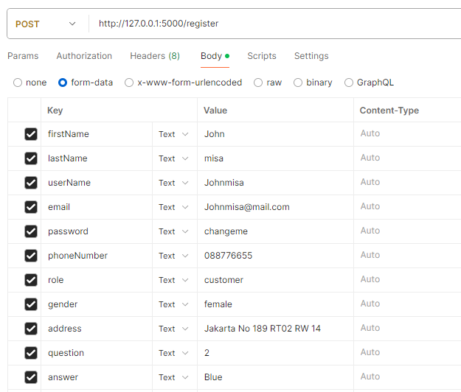

**\*Note:**

Role = customer atau seller

Gender = male atau female

Question = interger input ,berdasarkan pertanyaan dari ID master_question

Answer = jawaban berdasarkan pertanyaan dari secret question

**Expected Result:**

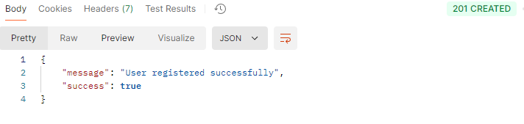

* 1. **@userBp.route(‘/userprofile’ , methods = [‘GET’]**

## **Detail :** show all userprofile

**Expected Result :**

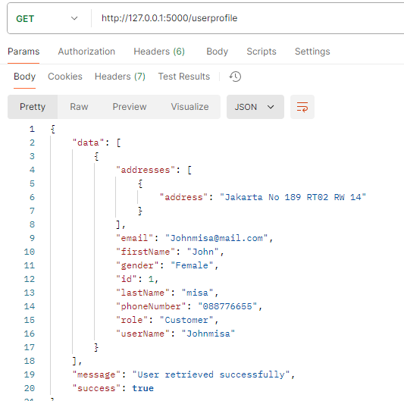

* 1. **@userBp.route(‘/login’ , methods = [‘POST’]**

## **Detail :** User Login

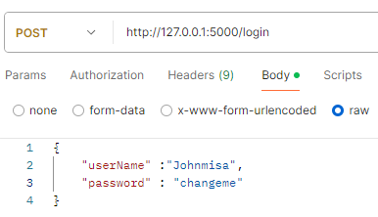**Expected Input :**

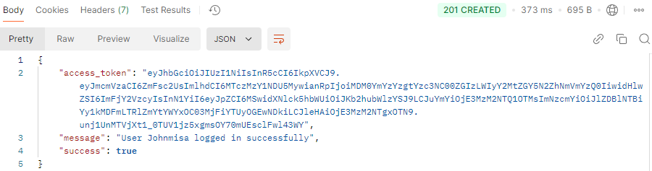**Expected Result :**

* 1. **@userBp.route('/login/forgotpassword', methods=['POST'])**

## **Detail :** user forgetpassword

**Expected Input :**

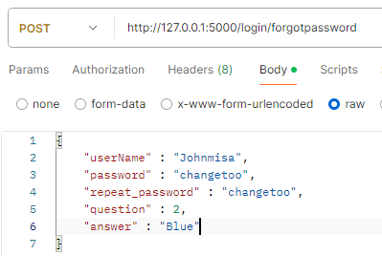

*Note :

Password dan repeat password = create new password

Question = base on user register select master_question

Answer = base on answer on register

**Expected Result :**

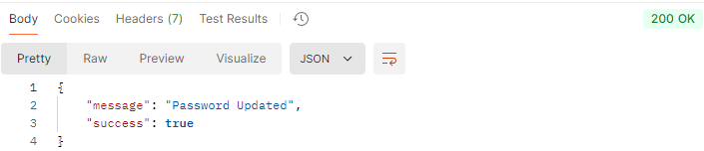

* 1. **@userBp.route('/updatepassword', methods=['PUT'])**

## **Detail :** update new password

Note: user must login first

**Expected Input:**

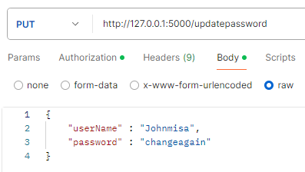

**Expected Result :**

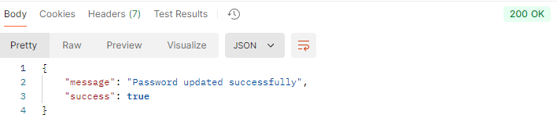

* 1. **@userBp.route('/addaddress', methods=['POST'])**

## **Detail :** Add another address for user

**Note:** user must login first

**Expected Input:**

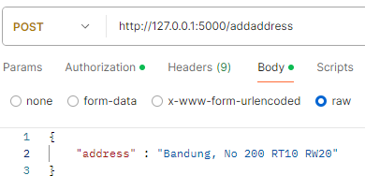

**Expected Result:**

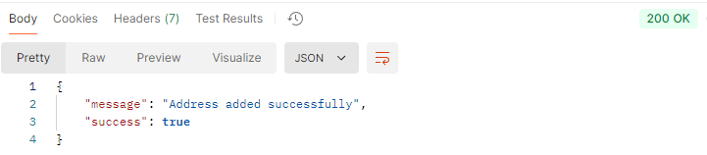

* 1. **@userBp.route('/deleteaddress/<int:id>', methods=['DELETE'])**

## **Detail :** Delete existing address

**Note:**

**-** User must login first

**-** Delete address base on id Address <int:id>

**Expected Result:**

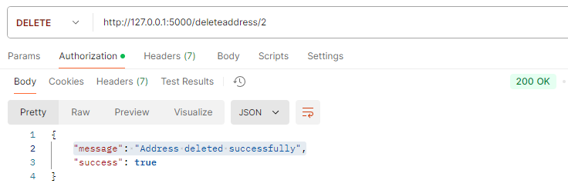

* 1. **@userBp.route('/userprofile', methods=['PUT'])**

## **Detail :** Update userprofile

**Note:**

* + User must login first
  + The key parameter used is free, depending on the data that will be updated (except : Role)

**Sample Expected Input:**

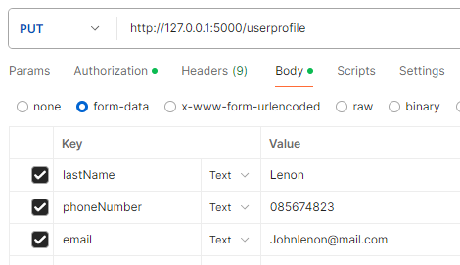

**Expected Result:**

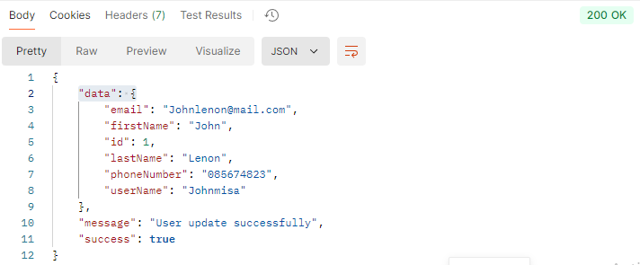

# Product Controller :

* 1. **@productBp.route('/product/addproduct', methods=['POST'])**

## **Detail :** add new product

**Note:** User must login first, and have Role = Seller

**Expected Input:**

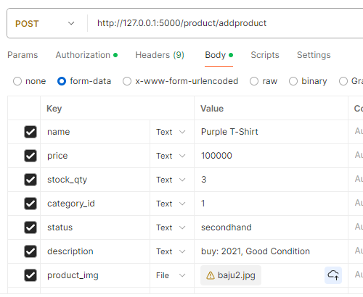

**Expected Result:**

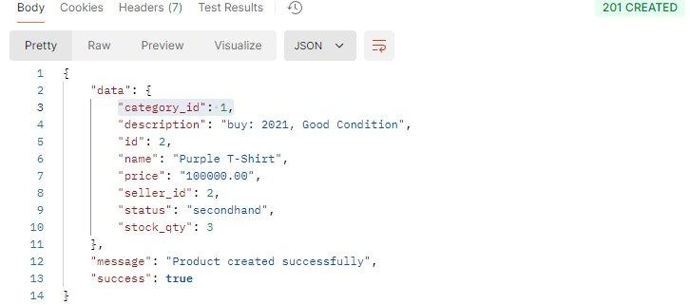

* 1. **@productBp.route('/product', methods=['GET'])**

## **Detail:** get all product item on database

**Expected Result:**

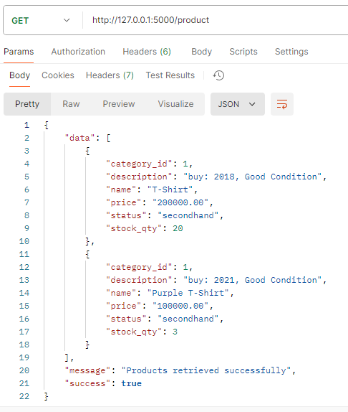

* 1. **@productBp.route('/product/<int:id>', methods=['GET'])**

## **Detail :** Show specific product base on id product

**Expected Result:**

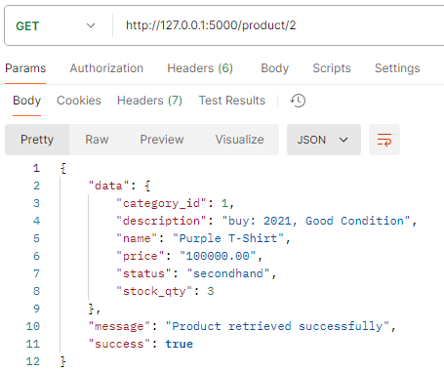

* 1. **@productBp.route('/product/<int:id>/addimage', methods=['POST'])**

## **Detail :** add new image to existing product

**Note:** user must login first and have role seller

**Expected Input:**

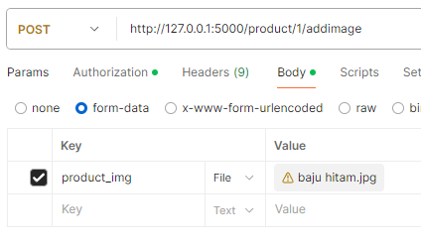

**Expected Result:**

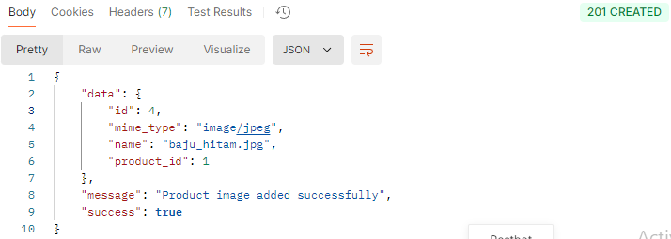

* 1. **@productBp.route('/product/<int:id>', methods=['PUT'])**

## **Detail :** update data from existing product

**Note:** user must login first, role must seller, and have product from user

**Expected Input:**

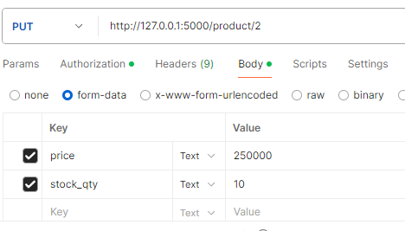

**Expected Result:**

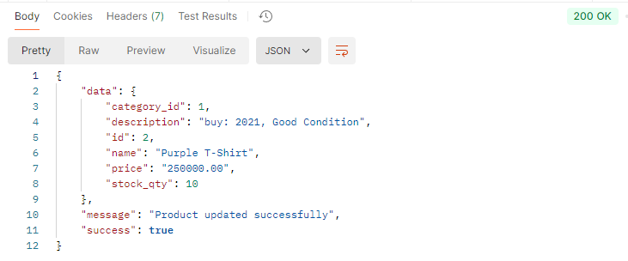

* 1. **@productBp.route('/product/<int:id>', methods=['DELETE'])**

## **Detail :** delete existing product

**Note:** User must login, role must seller, and user have authority for product, id is for product_id

**Expected Result:**

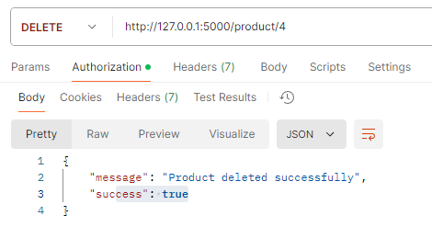

# Master_Question Controller :

* 1. **@masterBp.route('/masterquestion', methods=['GET'])**

## **Detail:** Get all list secret question

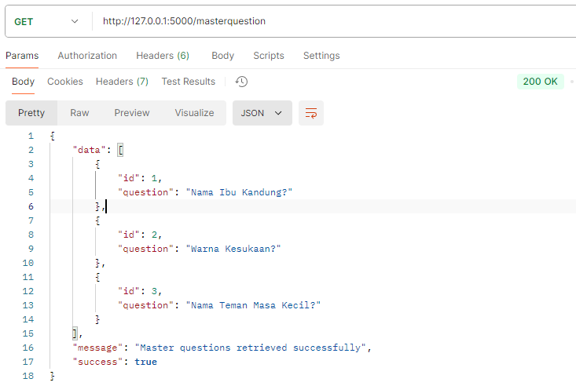**Expected Result:**

# Cart Controller :

* 1. **@cartBp.route('/cart', methods=['POST'])**

## **Detail :** add product to cart

**Note:** user must login first, role must customer

**Expected Input:**

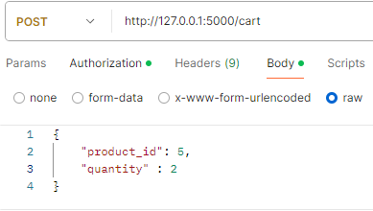

**Expected Result:**

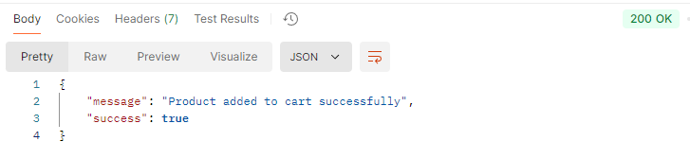

* 1. **@cartBp.route('/cart', methods=['GET'])**

## **Detail :** Show all product in cart

**Note:** user must login, role must customer, already add product to cart

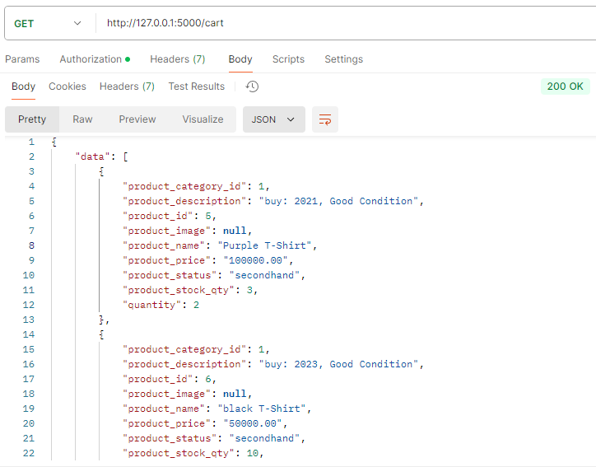**Expected Result:**

* 1. **@cartBp.route('/cart/<int:product_id>', methods=['PUT'])**

## **Detail :** edit items product in cart

**Note:** user must login, role must customer, already add product to cart

**Expected Input:**

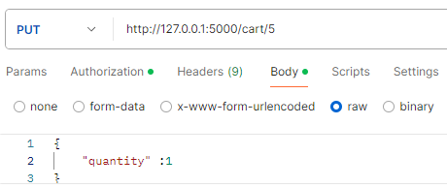

**Expected Result:**

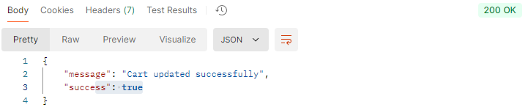

* 1. **@cartBp.route('/cart/<int:product_id>', methods=['DELETE'])**

## **Detail :** delete selected product from cart

**Note:** user must login, role must customer, already add product to cart

**Expected Result:**

